VIRTUALIZATION ESSENTIALS

yazan alshareef
Chapter 1: Understanding virtualization.
virtualization in computing:
Abstracting a physical resource into a logical (virtual) one to use it more efficiently.
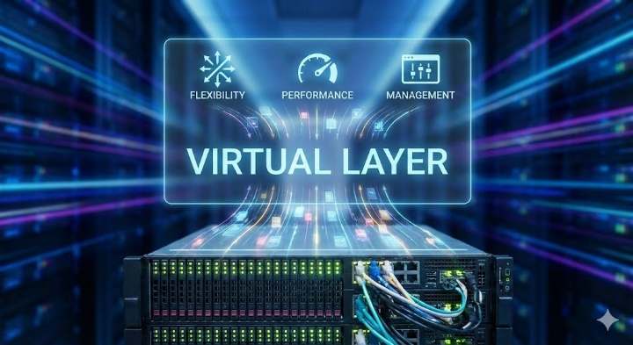
The focus here is computer virtualization, which means:
Running multiple virtual computers on a single physical machine.
Each virtual computer behaves as if it is a real, independent system.

A Virtual Machine (VM) is: complete virtual computer, Includes:
1.Virtual CPU 2. Virtual memory 3. Virtual storage 4. Virtual network
It runs an operating system just like a physical computer.
Virtual Machines
App | App | App
Os | Os | Os
Virtual Machine Monitor or Hypervisor
Physical server
- Hypervisor: is the software that provides the environment in which the VMs operate.
- VMM:- means virtual machine monitor.

- VMM needs to exhibit three properties in order to correctly satisfy their definition: الشروط الأساسية لنظام المحاكي
1.Fidelity: The environment it creates for the VM is essentially identical
to the original (hardware) physical machine.
2. Isolation or Safety The VMM must have complete control of the
system resources.
3.Performance: There should be little or no difference in performance
between the VM and a physical equivalent.

